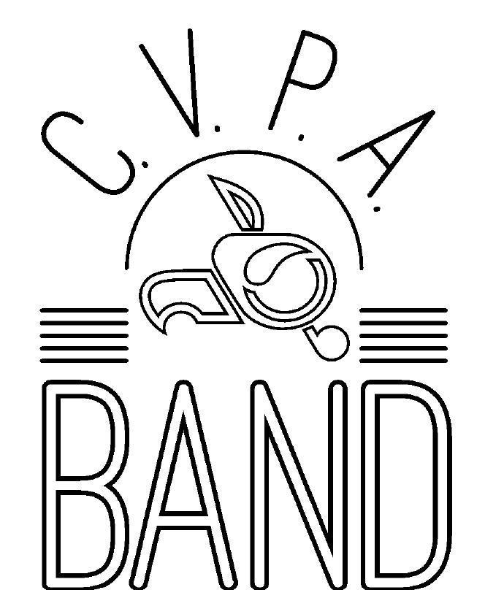

Handbook
2025-2026
Central Visual and Performing Arts High School
3125 S. Kingshighway Blvd.
St. Louis, MO 63139
314-771-2772

Dear Students, Parents and Guardians,
Welcome to the 2025-2026 school year and thank you for committing to the CVPA Band Program! Experts have concluded that the study of music helps with spatial reasoning, test taking, and overall quality of life! Factor in social skills, emotional development, leadership training, group interaction, aesthetic perception, music making, travel opportunities, and the discipline of being in an ensemble; I don’t know why anyone would not want to be involved. It is my esteemed pleasure to be the band director at CVPA and I am very excited for the music making that lies ahead of us.
This year will include hard work, good times, discipline, and many memorable experiences making music with your high school peers. Being a part of an ensemble is a completely unique experience and the information outlined in this handbook will clarify how we will reach our goals as a band. When an issue or disagreement arises, I will often refer students and parents to this handbook, as it is my goal that the policies and procedures outlined below will provide the structure, we need to be a successful band. Students are responsible for ‘owning’ the material in this book, adhering to the policies set forth and being an active participant in their music education. There are no excuses for not knowing or acting on the information within. Please read it carefully and contact me if you have any questions.
Sincerely,
Mr. Tyler Belliston
tyler.belliston@slps.org

Rules for a Respectful Classroom
-All school-wide policies will be followed -
-Be in your assigned seat with your instrument ready to play and materials (music, pencil, reeds, oil) by 5 minutes after the bell-
-When the conductor is on the podium or another student is called on to speak, listen and do not make sound-
-Absolutely no food or drink in the rehearsal area (water is acceptable)
-No cell phones or electronic devices allowed. It is the law.
-Treat your peers and the equipment with respect –
-Never leave the classroom without a pass-
-Keep your hands to yourself-
-At the end of class, put all materials away in their proper place when instructed-
Consequences:
● Verbal warning
● Loss of participation points
● Conference with the student during lunch or after school
● Parent phone call
● Office referral

Rewards:
● Productive and respectful rehearsals
● Outstanding performances that push your idea of what is possible
● Other incentives agreed upon as a group and approved by Mr. Belliston

Calendar of Important Events:
This will be updated throughout the year as later dates are solidified. Important due dates and commitments will always be posted in the classroom in advance. It is the student’s responsibility to clear their schedule and be in attendance for all full-band activities. If you need to reschedule work, be sure to talk to your employer ahead of time (at least 3 weeks prior). Excused absences will follow school policy; failure to responsibly resolve avoidable conflicts will result in a dramatic impact on your grade. This is a performing group that requires each individual’s contribution to be successful.

Performance opportunities (As of 8/8/25 subject to change)
Music at the Intersection…………………………………………………………………September 12th
Shaw Art Fair…………………………………………………….…………………………………October 4th
Metro 8 Registration Jazz and Concert Band ………………………………………. October 17th
Metro 8 Auditions Jazz and Concert Band ……………………………………………October 28th
All State Auditions…………………………………………….…………………………………December 6th

At this point and time, we do not know when our on school performances will be yet. There will be Showcases and a Combined Band and Choir Concert in Spring. Dates TBD

Instrument Rentals:
At the beginning of the year, each student will be issued a school owned instrument. The student will sign a bond agreement and assume responsibility for the proper care of the instrument. The rental program is free of charge to students and we have a small budget for repair and maintenance concerns. If damage comes to a school owned instrument as a result of neglect, misuse, or irresponsibility, the student is liable for damages incurred. Each student will also be issued a locker, lock, band folder, and curricular materials. These are to be kept safe, clean, and organized at all times. Your band locker is not a closet, pantry, warehouse, etc. Keeping our equipment clean and organized helps it last longer and saves our program money for more interesting things. There will be periodic locker, folder, and instrument checks to ensure that we are meeting this expectation.

Student Leadership:
This band is only as strong as we make it. Powerful musical performances require maturity and leadership on many different levels. Every member of the ensemble is in charge of his or her own attitude every day in rehearsal. Attitude is a small thing that makes a big difference; please choose wisely.
Section Leaders
There will be auditions in each section consisting of a major scale, a chromatic scale, prepared excerpts, and sight-reading. Auditions will be recorded by a fellow student and remain anonymous until they are evaluated by Mr. Belliston. Results will determine section leaders and part assignments. Section leaders are the individuals responsible for organizing and collaboratively leading sectionals, being the first to know their music, and bringing a positive and determined attitude to rehearsal. Audition results do not dictate your value to an ensemble: every part is crucial and every note needs your best. Each student is allotted a challenge in which they can try to move up a chair placement by repeating the audition process.
Band Officers
At the beginning of the year, elections will be held for four different officer positions in the ensemble. These selections should reflect musical as well as character leadership. A band officer should be someone who is deeply passionate about music and sets a serious, respectful tone in rehearsals. Band officers will have extra responsibilities to the ensemble outlined below and Mr. Belliston reserves the right to alter officer placement if these expectations are not met.
Co-Presidents: There will be two co-presidents in the band. These students will have a variety of leadership responsibilities. They are responsible for promoting a positive classroom climate and communicating with Mr. Belliston the needs, ideas, and feelings of fellow band members. Of course, any student is welcome to discuss matters with Mr. Belliston, but during officer meetings the co-presidents will serve as the voice of the ensemble. Co-presidents must demonstrate exemplary efforts in and outside of rehearsals.

Secretary: There will be one secretary who is responsible for helping with music collection and distribution, taking photos (band historian), and assisting in the office duties of the band. This should be a person who is responsible and organized.
Treasurer: There will be one treasurer who is in charge of forming committees and brainstorming possible fundraising efforts for the band. The treasurer will work closely with Mr. Belliston to ensure fundraisers receive the proper approval and are organized effectively.

Personal Practice:
There is no shortcut to an expressive, engaging musical performance. You must learn your music outside of rehearsal so that during class you can listen outside your own part and learn how you fit in with everyone else. Cramming practice before a performance is like staying up all night before a big test; you are bound to forget/make a mistake on a crucial detail because you have not given your mind and body enough time to OWN the material.
To help encourage practice this year we are implementing a Bi-weekly practice log, this will be for a grade. If I don’t see the paper, it goes in as zero. No late submissions will be accepted. For more look into the grading section.
There will still be random playing tests to ensure that no one is misrepresenting their practice times on the logs.

Performances:
The opportunity to perform is the showcase activity for this course. Performances will be worth 300 points and will be assessed in three different ways (100 points each). First, your attendance at the performance and ALL dress rehearsals leading up to the concert is mandatory. You will receive the full 100 points for being punctual (early is on time, on time is late), being prepared with necessary music and materials, wearing the appropriate dress, and having a positive attitude that reflects focus and determination. Second, the class period following a performance each musician will complete a performance reflection rubric, much like the scoring sheet used at contests. As an ensemble, we will listen to our performance and critically reflect on our strengths and weaknesses. Third, Mr. Belliston will evaluate the individual performance of each member using the same rubric.

Concert Attire: All students should wear a minimum of a
- White button-up collared shirt.
- Black Dress Pants
- Black Dress socks and shoes
- Girls may wear black dresses or a white blouse with black skirt, but the skirt/dress must go past the knees to avoid indecent exposure on stage.

Grading Policy:
Participation
- 30 points per week for being prepared, respectful, and ready to learn. You will always receive these points when you follow the Rules for a Respectful Classroom and try your best. Everyone starts with an ‘A’ for each week. Deductions will be applied when expectations are not met.

- In-class work including written assignments and in-class exercises will be additional points depending on the assignment. This encompasses class-work and playing tests.

Exams
- Concerts are 300 points, broken into three categories:
  - 1. Responsibility
  - 2. Your reflection and critique of the performance
  - 3. Mr. Belliston’s evaluation.
Benchmark Exam:
- All students are expected to be able to perform their major and melodic minor scales. At the end of each semester the students will perform these privately for Mr. Belliston to retain their status as a member of the advanced band. Remediation may be suggested if a student fails the benchmark exam.
Practice Logs:
- Practice logs will be due on the Friday we have class. (it should be about every 2 weeks), There will be no required amount of practice, just practice, the main focus for this assignment is to be mindful of your practice and be able to communicate what your goals are for each practice session and what was accomplished, it is also a way to communicate with Mr. B on what you need help with. These will be graded upon completion and upon due date. Can turn in a practice log up to only 1 week after due date.
Cell Phone Policy:
None. It is Law.

Band Dues:
In order to ensure a healthy and prosperous program, annual band dues will be implemented to provide the best experience possible for our students. With that in mind, I am asking that each band student pay an annual fee of $50. This money will go towards many items that are necessary to keep a successful band program running. These dues will pay for the following items:
1. Personalized Band T-Shirt
2. Flip Folder (wind instruments)
3. Lyre (wind instruments)
4. Stick/Mallet Bags (percussion instruments)
5. Honor Band/Solo Ensemble Registration Fees
6. Instrument Maintenance Kits
I understand that we all may not be able to come up with $50 all at once. Please reach out to me personally and we can set up a schedule of payments to make it easier. Even if it is just $1 a day. Band Dues will be due by Friday, November 7, 2025.

Please detach this sheet and return no later than Monday, September 8, 2025.
There are mandatory rehearsals and performances outside the school day for which attendance is required to fulfill grade requirements. By signing below, you state that you have read the above information and are responsible for the dates, commitments, rules, and policies set forth.
Student’s Signature: _____________________________________________________
Parent/guardian signature:________________________________________________
Preferred Phone Contact:_________________________________________________
Email:__________________________________________________________________
Additional questions or comments:________________________________________
________________________________________________________________________________________________________________________________________________________________________________________________________________________________________________________________________________________________________________________________________________________________________

